**Abstract Guidelines**

XIII International Scientific Conference

**“Microbial biotechnologies: fundamental and applied aspects”,**

Minsk, 6–9 June 2023

**Abstracts** in Russian or English languages are submitted via on-line system available at official website of the Institute of Microbiology, Belarus Academy of Sciences (<https://mbio.bas-net.by/2023/submission_en.php>).

**File size** up to 2 Мb.

**Abstract volume** up to **2 pages** processed in any text editor program with extensions **.doc, .docx, .odt** or **.rtf**.

**Paper sheet size** А4 (297 × 210 mm), book orientation, margins 20 mm, indentation 10 mm, justified alignment.

**Font** Times New Roman, 14 pt, line spacing 18 pt. Automatic word hyphenation at line ends is mandatory. The pages are not numbered.

**Abstract title:** Times New Roman font, 17 pt, bold typeface, left alignment. **Surnames and initials of the authors:** Times New Roman font, 14 pt, bold typeface, left alignment. **Name of the Institution:** Times New Roman font, 13 pt, italic typeface, left alignment.

**Tables** are generated via Table option and their content is formed using font Times New Roman 12 pt, at ordinary spacing. Table heading specifications: Times New Roman 14 pt font, ordinary spacing, left alignment.

**Figures** must be of reasonable size and quality to view. Composite figures should be grouped. Capture of the figure should be typed in Times New Roman 14 pt, bold typeface, at ordinary spacing, center alignment. Figure legends should be typed in Times New Roman, 12 pt, ordinary spacing, placed between the figure and its capture.

**References** numbered sequentially in the order of their citation in the text are inserted within square brackets. The list of references finalizing the abstract is performed in Times New Roman 12 pt at ordinary spacing, left alignment (citation style according to Rules of Supreme Attestation Commission of the Republic of Belarus: <https://vak.gov.by/en/bibliographicDescription>. We encourage you to generate reference lists automatically using Zotero program and the VAK9 citation style for it (<http://bio.bsu.by/temp/zotero/gost-r-7-0-5-2008-VAK9.csl>).

**Special symbols** (e.g. β, ×, ±) should be introduced into the text via the option “Insert → Symbol”. **Latin text** are italicized (e.g. *Aspergillus niger* BIM F‑65).

Authors of accepted abstracts carry responsibility for authenticity of presented results, compliance with authorship rights, accuracy of citations, legalization of data not subjected to public disclosure.

The Organizing Committee reserves the right to reject abstracts not meeting the established deadline, thematic profile or format criteria and to modify the text in a way not affecting its scientific content.

The authors will receive an e-mail confirmation of abstract receipt by Organizing Committee. In case such confirmation is delayed please contact Organizing Committee by e-mail: conference@mbio.bas-net.by.

*Abstract template*

### Molecular-genetic analysis of determinants, coding for synthesis of antimicrobial metabolites in bacteria of genus *Bacillus*

**Berezhny A.1, Petrov P.1,2, Ivanov V.2**

*1Institute of Microbiology NAS Belarus, Minsk, Belarus,  
e-mail: name@mail.ru*

*2Faculty of Chemistry, M.V. Lomonosov Moscow State University, Moscow, Russia*

Bacteria of genus *Bacillus* are producers of a wide spectrum of biologically active substances, including antibiotics, surface-active agents, enzymes, etc., which determine their application for development of biopreparations for plant protection [1]. The most well-known antagonistically active metabolites of bacilli are lipopeptides of surfactin (fig. 1) and iturin groups [2, 3].

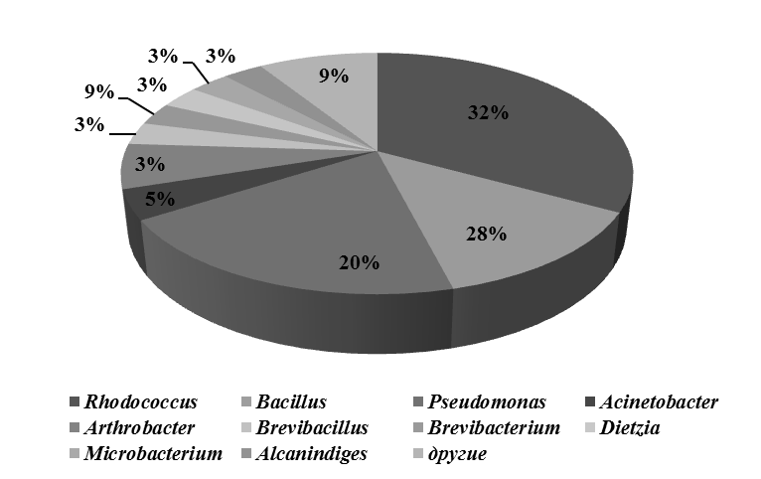

**Figure 1** – Taxonomic affiliation of studied test-cultures of microorganisms

One of the prospective directions of bioremediation of environment is introduction of active microorganisms-destructors of xenobiotics in soil, contaminated with pesticides (Tab. 2).

**Table 2** – Growth of bacteria at different oil concentrations

|  |  |  |  |  |  |  |
| --- | --- | --- | --- | --- | --- | --- |
| Oil concentration,  % | Strain | | | | | |
| 90 | 102 | 108 | 109 | 112 | 114 |
| 5 | 25 | 22 | 30 | 24 | 35 | 32 |
| 10 | 15 | 13 | 11 | 12 | 28 | 23 |
| 15 | 12 | 10 | 10 | 10 | 24 | 22 |
| 20 | 9 | 7 | 7 | 8 | 16 | 18 |
| 50 | 5 | 4 | 5 | 6 | 8 | 10 |

***Literature***

1. Harpin induces disease resistance in *Arabidopsis* through the systemic acquired resistance pathway mediated by salicylic acid and the NIM1 gene / H. Dong [et al.] // Plant J. – 1999. – Vol. 20, № 2. – P. 207-215.

3. Fontanilla, M. Effects of the foliar-applied protein “Harpin(Ea)” (messenger) on tomatoes infected with *Phytophthora infestans* / M. Fontanilla, M. Montes, R. De Prado // Communications in agricultural and applied biological sciences. – 2005. – Vol. 70, № 3. – P. 41-45.